中北大学计算机与控制工程学院
实验报告
课程名称 面向对象程序设计 学号 学生姓名 辅导教师 韩慧妍
专业 | 计算机科学与技术 | 实验室名称 | 软件基础实验室 | 实验时间
1．实验名称
实验七 多态和重载
2. 实验目的
（1）掌握运算符重载的方法
（2）学习使用虚函数实现动态多态性。
3. 实验内容
（1）定义Point类，有坐标x，y两个成员变量；对Point类重载“++”(自增)、“一一”(自减)运算符，实现对坐标值的改变。
（2）定义一个车(vehicle)基类，有Run、Stop等成员函数，由此派生出自行车(bicycle)类、汽车(motorcar)类，从bicycle和motorcar派生出摩托车(motorcycle)类，它们都有Run、Stop等成员函数。观察虚函数的作用。
4. 实验原理或流程图
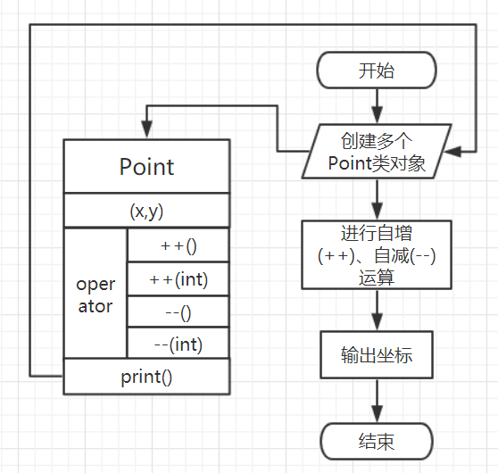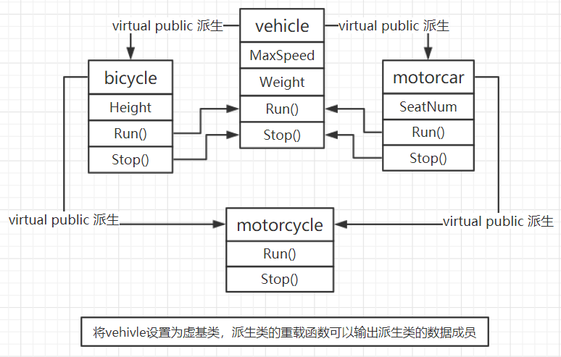

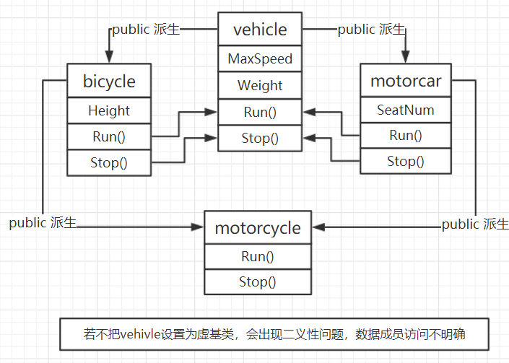

5. 实验过程或源代码
（1）
【Point.h】
#include <iostream>
using namespace std;

class Point
{
public:
Point(double r = 0,double i = 0);
~Point();
Point operator ++();
Point operator ++(int);
Point operator --();
Point operator --(int);
void print() const;

private:
double x;
double y;
};

Point::Point(double r,double i)
{
x = r;
y = i;
cout << "Point constructor is called." << endl;
}

Point Point::operator++()
{
x++;
y++;
return *this;
}

Point Point::operator++(int i)
{
return Point(x++,y++);
}

Point Point::operator--()
{
x--;
y--;
return *this;
}

Point Point::operator--(int i)
{
return Point(x --, y --);
}

Point::~Point()
{
cout << "Point destructor is called." << endl;
}

void Point::print() const
{
cout << "(" << x << "," << y << ")" << endl;
}

【Main.cpp】
#include "Point.h"

int main()
{
Point p1(3, 6), p2, p3, p4, p5;
p2 = p1++;
p3 = ++p2;
p4 = p3--;
p5 = --p4;
p1.print();
p2.print();
p3.print();
p4.print();
p5.print();
return 0;
}

（2）
【vehicle.h】
#include <iostream>
#include <string>
using namespace std;

class vehicle
{
public:
vehicle(int maxSpeed, double weight)
{
MaxSpeed = maxSpeed;
Weight = weight;
cout << "vehicle constructor is called." << endl;
}
~vehicle() { cout << "vehicle destructor is called." << endl; }
virtual void show();
void Run() { MaxSpeed = 5; }
void Stop() { MaxSpeed = 0; }
protected:
int MaxSpeed;
double Weight;
};

void vehicle::show()
{
cout << "MaxSpeed: " << MaxSpeed << "km/h" << endl;
cout << "Weight: " << Weight << "kg" << endl << endl;
}

【bicycle.h】
#include "vehicle.h"

class bicycle : virtual public vehicle
{
public:

bicycle(int maxSpeed, double weight, double height) :vehicle(maxSpeed, weight)
{
Height = height;
cout << "bicycle constructor is called." << endl;
}
~bicycle() { cout << "bicycle destructor is called." << endl; }
virtual void show();
void Run() { MaxSpeed = 20; }
void Stop() { MaxSpeed = 0; }
protected:
double Height;
};

void bicycle::show()
{
cout << "MaxSpeed: " << MaxSpeed << "km/h" << endl;
cout << "Weight: " << Weight << "kg" << endl;
cout << "Height: " << Height << "m" << endl << endl;
}

【motorcar.h】
#include "bicycle.h"

class motorcar : virtual public vehicle
{
public:
motorcar(int maxSpeed, double weight, int seatNum)
:vehicle(maxSpeed, weight), SeatNum(seatNum)
{
cout << "motorcar constructor is called." << endl;
}
~motorcar() { cout << "motorcar destructor is called." << endl; }
virtual void show();
void Run() { MaxSpeed = 140; }
void Stop() { MaxSpeed = 0; }

protected:
int SeatNum;
};

void motorcar::show()
{
cout << "MaxSpeed: " << MaxSpeed << "km/h" << endl;
cout << "Weight: " << Weight << "kg" << endl;
cout << "SeadtNum: " << SeatNum << endl << endl;
}

【motorcycle.h】
#include "motorcar.h"

class motorcycle : public bicycle, public motorcar
{
public:
motorcycle(int maxSpeed, double weight, double height, int seatNum)
:vehicle(maxSpeed, weight), bicycle(maxSpeed, weight, height),
motorcar(maxSpeed, weight, seatNum)
{
cout << "motorcycle constructor is called." << endl;
}

virtual void show()
{
cout << "MaxSpeed: " << MaxSpeed << "km/h" << endl;
cout << "Weight: " << Weight << "kg" << endl;
cout << "Height: " << Height << "m" << endl;
cout << "SeadtNum: " << SeatNum << endl << endl;
}
void Run() { MaxSpeed = 50; }
void Stop() { MaxSpeed = 0; }

~motorcycle() { cout << "motorcycle destructor is called." << endl; }
protected:

};

【Main.cpp】
#include "motorcycle.h"

int main()
{
vehicle veh(0, 120.0);
bicycle bike(0, 85.0, 170.0);
motorcar car(0, 135.0, 4);
motorcycle motor(0, 85.0, 170.0, 4);
veh.Run();
bike.Run();
car.Run();
motor.Run();

vehicle *pt = &veh;
pt->show();

pt = &bike;
pt->show();

pt = &motor;
pt->show();
return 0;
}

6．实验结论及心得
（1）运算符重载输出结果：
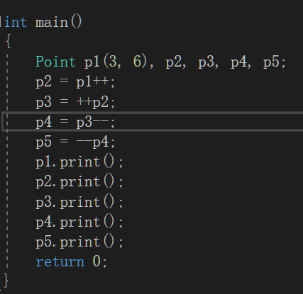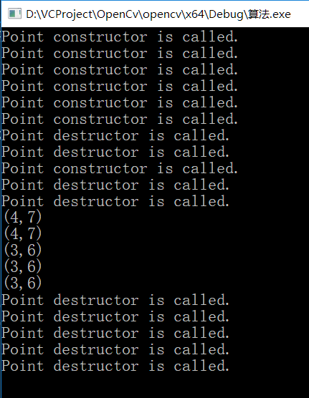

（2）使用虚函数实现动态多态性：
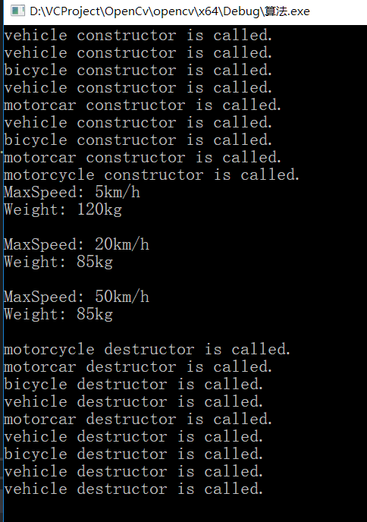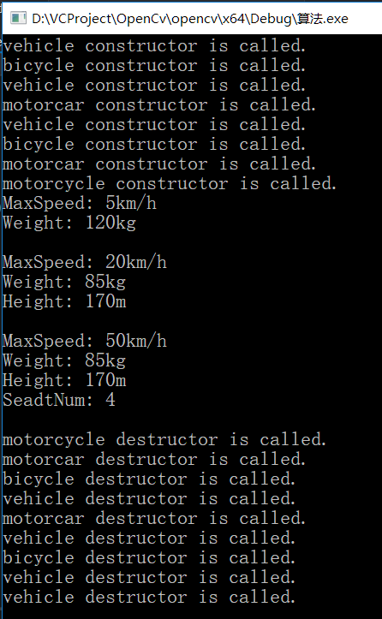
未使用虚函数 使用虚函数

虚函数的作用是允许在派生类当中重新定义与基类同名的函数，并且可以通过基类指针或引用来访问基类和派生类中的同名函数。
vehicle中的show函数的作用是输出车的基本数据，bicycle类中的show函数的作用是输出自行车的数据，motorcycle类中的show函数的作用是输出摩托车的数据，三者的作用是不同的。在主函数中定义了指向基类对象的指针变量pt,并先使pt指向vehicle1 ,用pt->show()输出基类对象vehicle1的全部数据成员，然后使pt指向bike,再调用pt->show(),企图输出bike的全部数据成员,但实际上只输出了vehicle1中的基类的数据成员,说明它并没有调bike中的display函数,而是调用了vehicle1的display函数。
使用虚函数就能解决这个问题，将基类的show函数声明为虚函数，只用一种形式pt->show()，便可输出bicycle跟motorcycle的全部数据。

